STUDENT RECORDS CRUD API

Node.js + Express.js + MongoDB + Mongoose

2520030583

Step 1: Check Node.js

node --version
npm --version

Step 2:
Open VS Code
- Open VS Code.
- Click File → Open Folder.
- Create a folder named StudentRecordsAPI.
- Select the folder and click Select Folder.

Step 3 :
Terminal → New Terminal
You should see a path ending with StudentRecordsAPI.
Step 4:
npm init -y
This creates package.json.

npm install express mongoose
Install nodemon as a development dependency:
npm install --save-dev nodemon

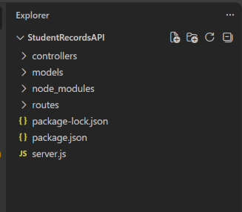

Step 5:
OPEN package.json
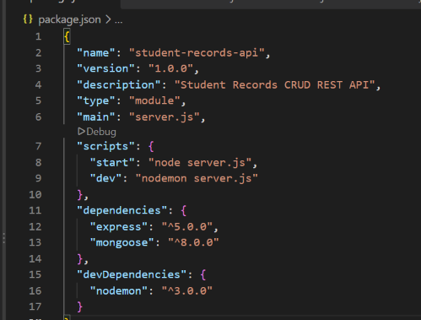

Step 6:
Open a NEW Command Prompt and type:
mongosh

Or open
Mongodb atlas and sign in
then
Open 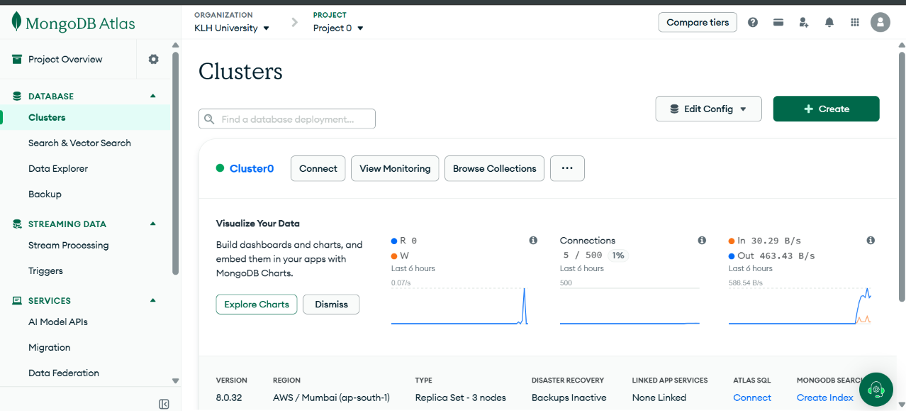

Click connect 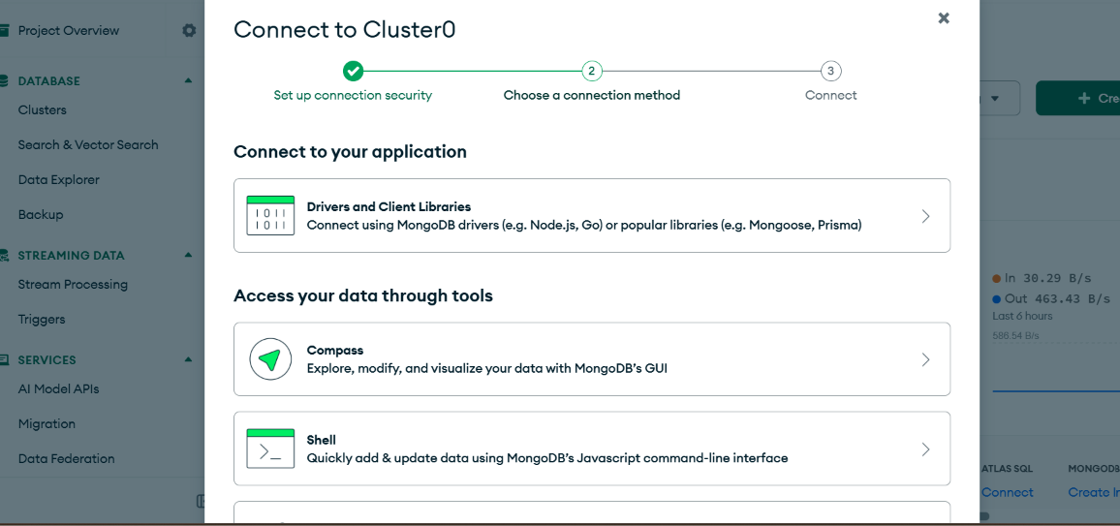

Click Drivers and client Libraries
Find the url
and copy it
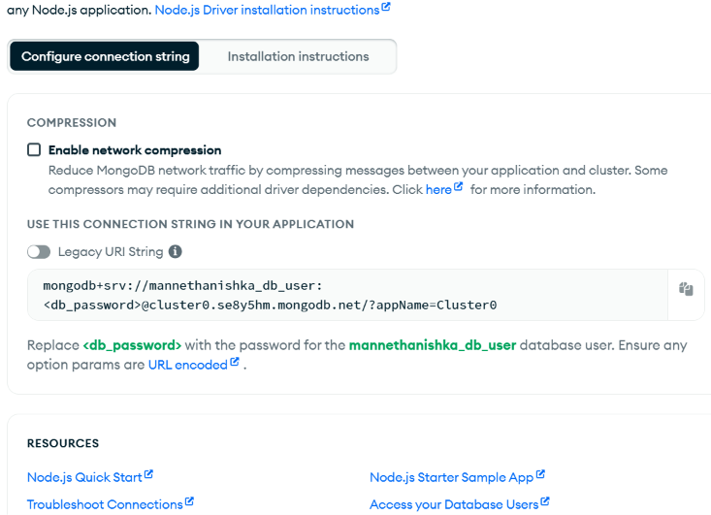

Step 7:
Paste it in the server.js
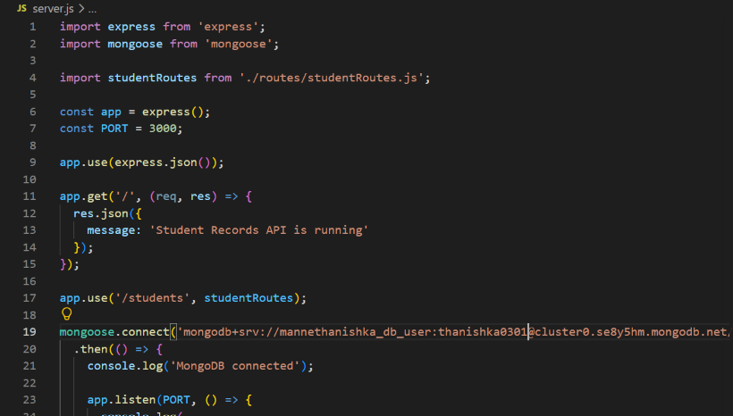

Step 8:
Create the Project Folder Structure
In the VS Code Explorer, create the following files and folders:
StudentRecordsAPI/
│
├── controllers/
│ └── studentController.js
│
├── models/
│ └── Student.js
│
├── routes/
│ └── studentRoutes.js
│
├── server.js
├── package.json
├── package-lock.json
└── node_modules/

Step 9:
Open student model
ANd paste
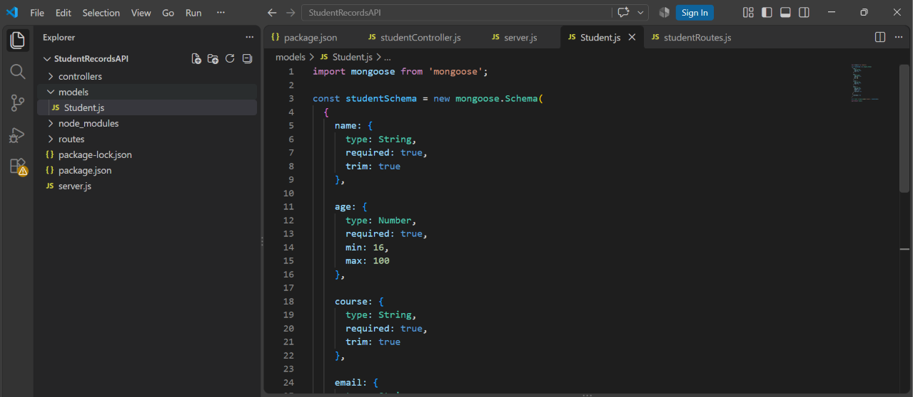

Step 10:
studentController.js
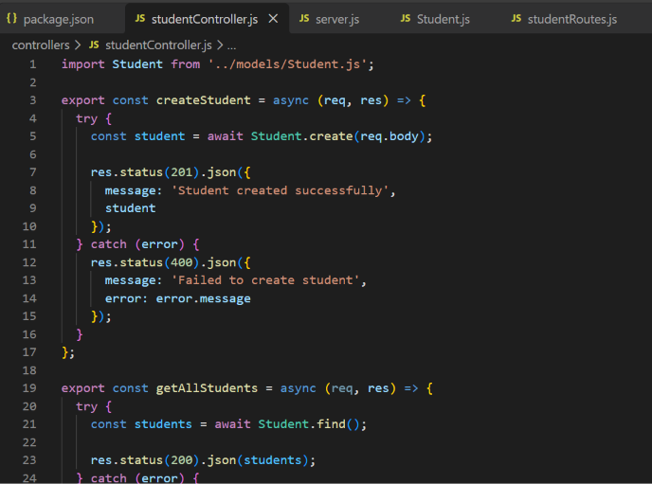

Step 11:
studentRoutes.js and enter:
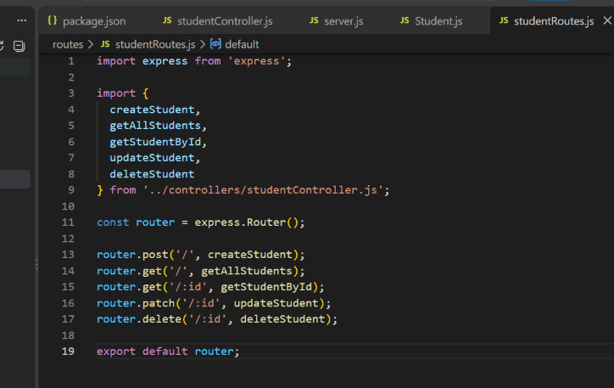

Step 12:
In terminal
npm run dev
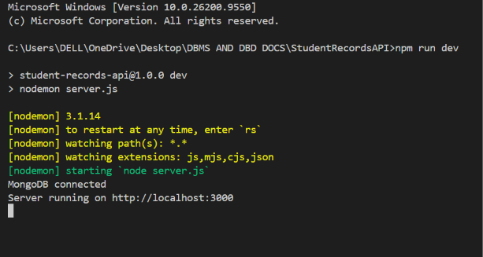

Step 13:
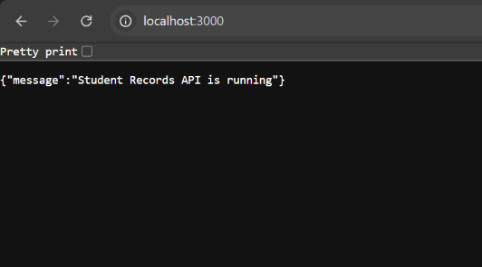
Step 14:

Test the CRUD API Using Postman

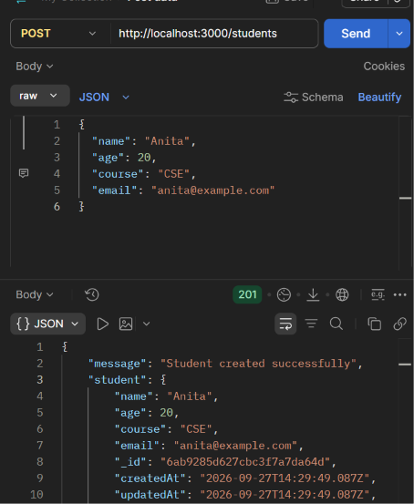

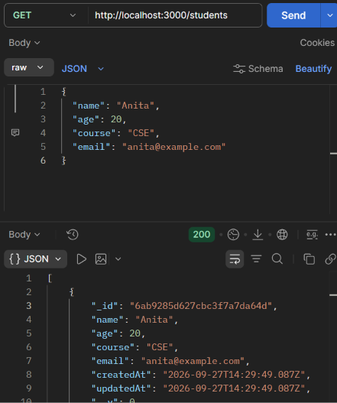
Like this do patch and delete
Step 15:
Select PATCH.
Enter http://localhost:3000/students/STUDENT_ID.
Select Body → raw → JSON.
Enter the fields to change.
Click Send.
{
"age": 21,
"course": "AI & DS"
}
Expected status: 200 OK.

Step 16:
Delete

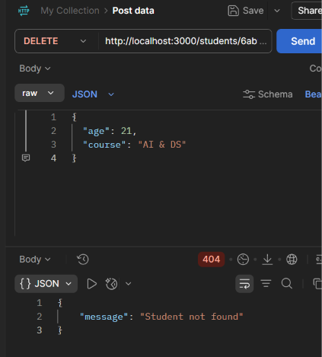

Step 17:
Verify Data in MongoDB
Open atlas and
Databases --> cluster --> Browse collections
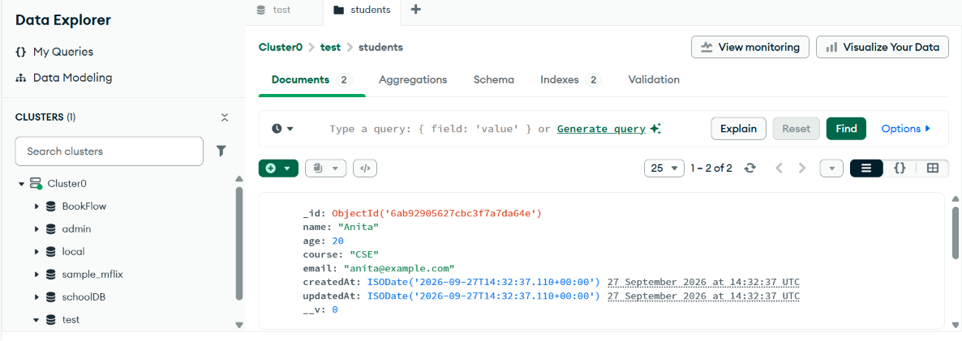

Final Project Architecture
Student Records REST API
Client / Postman
↓
Node.js
↓
Express.js
↓
Routes
↓
Controllers
↓
Mongoose
↓
MongoDB
Core operations:
POST /students
GET /students
GET /students/:id
PATCH /students/:id
DELETE /students/:id
Complete the CRUD project first. Authentication/JWT, Passport, Socket.io, testing, search, and pagination can then be added as separate extensions.

